project report template

1.introduction

1.1 overview

With Canva's wide selection of templates and easy-to-use drag and drop certificate generator, you can come up with the certificate you need in minutes, no design experience needed! Add high-quality images and illustrations, choose from over a hundred fonts and customize colors in a few clicks.

1.2 purpose

What is the purpose of certificate template?

A certificate template defines the policies and rules that a CA uses when a request for a certificate is received. Many built-in templates can be viewed using the Certificate Templates

2.problem definition & desine thinking

2.1 empathy map

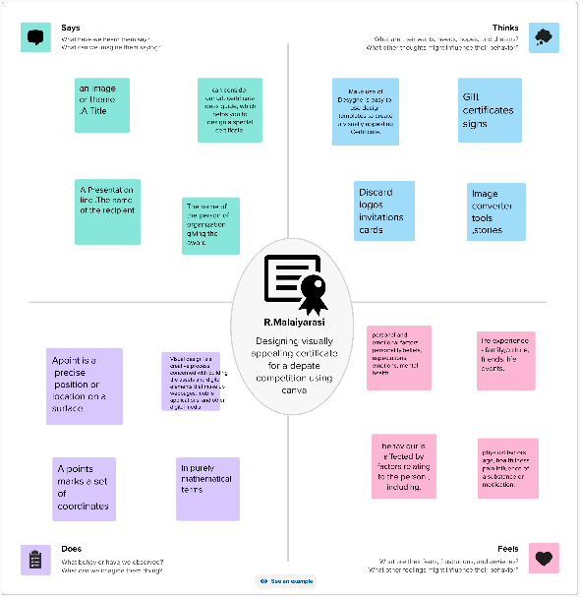

2.2 Brainstorming

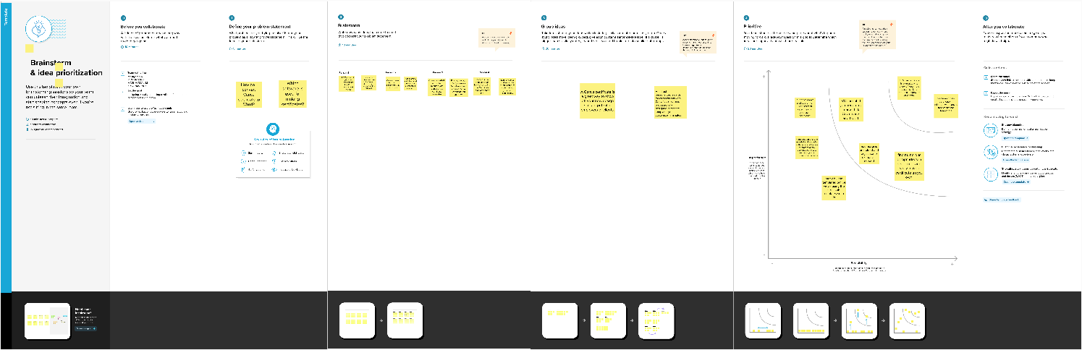

3. Resul

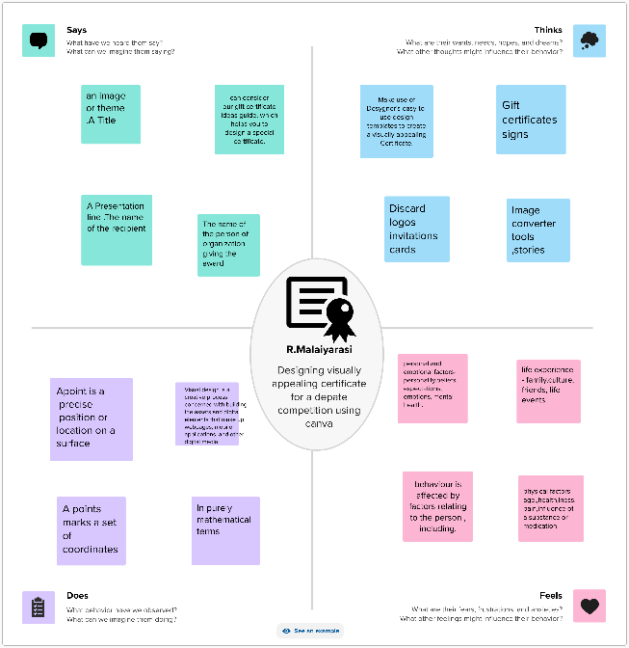 Empathy map

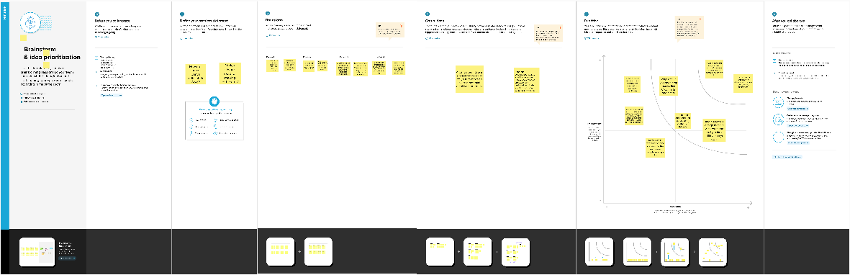 brainstormin map

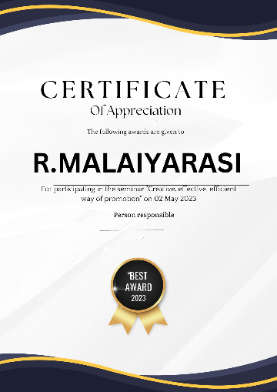 canva

4. advantages

You can choose from a variety of templates inclusive, but not limited

layout of the platform to guided templates, basically a drag and drop design platform.

DISADVANTAGE

When multiple businesses use the same content, or content follows Canva’s brand and style, content can appear generic.

 Canva’s contribution is growing every month, there is a limitation to template designs and stock photography.

*5. APPLICATIONS*

1. Design your certificate of participation yourself. ...
2. Use the certificate of participation template available online. ...
3. Use a professional and intuitive certificate maker (the fastest way!)
4. Use graphic design tools. ...
5. Hire a designer.

6.CONCLUSION

“This certificate is awarded to [Name] in recognition of their successful completion of [Course/Program/Training Name] on [Date]. Your hard work, dedication, and commitment to learning have enabled you to achieve this milestone, and we are proud to recognize your accomplishment.”

7.FUTURE SCOPE

Permits creating comments and replying to comment threads on a design the user has access to.

icanva uptate the very fast and quality desineand ake easily.,